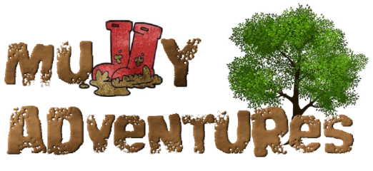

Party on the Farm Request Form

Name of organiser:

Who’s party is it?

How old will they be?

Preferred date:

Preferred time:

**What’s Included?**

* A 45min-1 hour walk around the farm with the opportunity to interact with animals and see machinery up close.
* 1 hour of ‘farm play’ with ride on tractors, small world play, playhouses etc. in our lovely farm courtyard next to the chickens which will be dressed with bunting to celebrate the day.
* use of our Sussex Barn in case of bad weather and to set up any food tables.

**What do you need to bring?**

* food and drink for your guests should you wish to serve it.

**Cost:** £150 for up to 20 children

**Optional extras– please tick if you would like them**

* 250ml bottle of milkshake from The Milk Hut £3 per head

**Booking and Cancellation Policy**

Please pay £50 deposit to secure your date, with the balance payable 48 hours before the party starts.

In the event we have to cancel due to bad weather or illness we will discuss with you options for postponing the party or refunding in full. Unfortunately we offer no refund if **you** have to cancel but with 48hours notice will do our best to find an alternative date.

Please make any payments to: Esther Jewitt 18503864 60-83-71

If you have any questions my number is 07824 861949