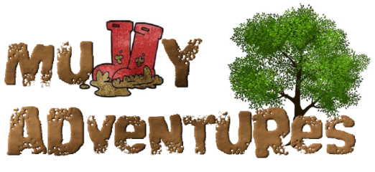

Forest School Party Request Form

Name of organiser:

Who’s party is it?

How old will they be?

Is there a theme you would like for the party?

(i.e. fairies, dinosaurs, explorers, rainbows, minibeasts, pirates etc)

Preferred date:

Preferred time:

**What’s Included?**

* A 2 hour fun-filled party held in our private historic woodland run by a fully qualified teacher and forest school leader
* 3 activities for party-goers to complete
* paper ‘party’ bags for any creations to be taken home in
* den building, mud kitchen, slackline, bug hunt, hammocks etc.

**What do you need to bring?**

* food and drink for your guests if you wish to serve it (please make sure you give yourself enough time before the party starts to get this set up).

**Cost:** £200 for up to 30 children

**Optional extras– please tick if you would like them**

* central fire + s’mores (marshmallows with chocolate biscuits) £50
* Gutter Pudding (selection of brownies,cakes, sweets, cream etc served in a gutter) £2 per head
* 250ml bottle of milkshake from The Milk Hut £3 per head

**Booking and Cancellation Policy**

Please pay £50 deposit to secure your date, with the balance payable 48 hours before the party starts.

In the event we have to cancel due to bad weather or illness we will discuss with you options for postponing the party or refunding in full. Unfortunately we offer no refund if **you** have to cancel but with 48hours notice will do our best to find an alternative date.

Please make any payments to: Esther Jewitt 18503864 60-83-71

If you have any questions my number is 07824 861949